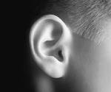
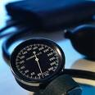
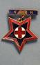
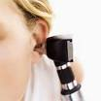
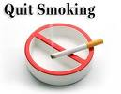
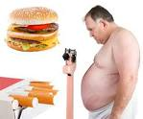
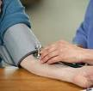
Nursing Services
15 MIN APPOINTMENTS: Blood pressure checks
Finger prick blood sugar tests
Injections as prescribed by your GP
Pregnancy tests
Vision tests
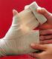
Suture removal
Liquid nitrogen (lesion to be diagnosed by doctor)
Sexual health services (free for 19 years and younger)
Emergency contraception
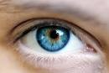
Cardiovascular risk assessments
Treatment of urinary tract infections in adults
Urine drug screening

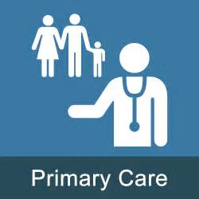
30 – 45 MIN APPOINTMENTS: Long-term Condition Management
Childhood immunisations
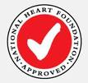
Travel health and non-funded immunisations
Cervical smear screening
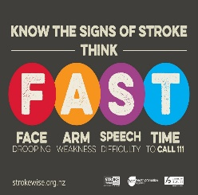
Diabetes education and management
Insulin starts
Asthma education and spirometry
Dressing changes and wound management
Electrocardiograph (ECG)
Ear syringes
Audiometry
Smoking cessation and support
Intravenous Infusion’s - Aclasta (for osteoporosis)
PLEASE ASK AT RECEPTION TO BOOK YOUR NURSE APPOINTMENT

